Measured and Estimated Performance of a Fleet of Shaded PV Systems with String- and Module-level Inverters

Sara MacAlpine, Chris Deline, Aron Dobos (Janine Freeman? Others?)

### National Renewable Energy Laboratory (NREL), Golden, Colorado, USA

***Abstract*  — This work assesses the performance of XX residential systems under a variety of shading conditions, some equipped with either string-level or module-level inverters. The presence of partial shading on PV arrays has been found to negatively impact system performance, sometimes in a nonlinear fashion, depending on the configuration and the number of independent maximum-power-point tracking channels in the PV system. Field performance is compared with annual PV performance models accounting for partial shade – System Advisor Model (SAM) and PVSyst. The extent of shade on the PV system is assessed by multiple techniques, including on-site surveys and 3D obstruction modeling (and aerial imagery?). The impact of shade is modeled by either a non-linear performance model or assumption of linear impact with shade, depending on the inverter type. The overall mean bias error and RMS errors of the shaded PV performance models are XX% and XX% respectively, for systems showing between 10%-30% performance loss due to shade. This is comparable to model accuracy for unshaded PV systems, indicating that the presence of shade does not necessarily contribute additional uncertainty to model predictions for well-modeled systems. In particular, the use of a detailed 3D model results in improved accuracy over simpler site survey methods, although proper description of shade obstructions is a prerequisite for improved accuracy.**

### *Index Terms* — modeling, photovoltaic systems, shading, solar energy.

### 1 Introduction

Solar photovoltaic (PV) distributed generation (DG) has certain advantages over large-scale PV systems such as reduced transmission and distribution cost [[1],[2]] and leveraging existing building stock [[3],[4],[5]]. Building geometries and landscapes of DG PV systems in urban and suburban environments often create situations though, in which arrays are partially shaded during a portion of their operating hours. Partial shading, although not ideal, does not necessarily preclude the financial viability of a PV installation; the resulting energy losses may be mitigated by use of distributed maximum-power point tracking (DMPPT) electronics [[6],[7],[8],[9]], or the shade loss may be insignificant, depending on the location and extent of shade obstructions relative to the array. To maximize the value to the customer, the impact of partial shading on a proposed PV system's performance must be predicted accurately.

The initial challenge in estimating the performance impact of nearby shade obstructions is to accurately model the position of the obstruction, and the reduction in irradiance across the PV system from resulting shadows. This has historically been accomplished by using on-site survey imaging tools [[10],[11]]. Other increasingly popular methods include aerial Light Detection and Ranging (LiDAR) analysis [[12],[13]], geographic information systems (GIS) analysis [[14],[15]], and 3D CAD modeling [[16],[17] ref Dobos if anything already exists]. Detail on the 3D CAD methodology that we used to describe obstruction shade conditions in this work will be discussed in Section 2.

A second challenge is to identify the PV performance impact from reduced and non-uniform irradiance across the PV system. Partial shade losses arise both from the reduced irradiance within the shaded area, as well as current and voltage mismatch between shaded and unshaded sections of the PV system [[18], others? Bishop?]. Although the loss from reduced irradiance cannot be recovered, mismatch losses may be recovered by the use of DMPPT electronics within the system [re-cite references 6-9? more references?]. Therefore, it is important to understand the system topology before attempting to calculate shade and mismatch performance losses. Systems equipped with central inverters without DMPPT suffer greater-than-linear losses under shaded conditions. These losses can be calculated directly by tabulating the IV-curve response at the cell or module level [[19],[20],[21], [22], [23]]. Although this provides a full and accurate solution, computation time is typically too great for integration into annual performance simulation programs like NREL's System Advisor Model (SAM) [[24]] or PVWatts [[25]].

Previous efforts have simplified the question of shade’s performance impact, either by restricting the shade geometry to that of regular inter-row self-shading [[26],[27]]; by simplifying the module IV curve description [[28],[29]]; or by applying an empirical “shade factor” to the area of shade extent [18,[30]]. Here we build on a previous description of a hybrid solution [[31]] that pre-computes loss factors for a wide variety of shading scenarios, based on a detailed cell-level model. This method has been experimentally validated, and is currently available through NREL’s SAM software, and also available as a standalone module here [provide web link when it’s available]. We will provide additional detail on this method in Section 3. We will also describe the much simpler scenario of PV system performance where loss is proportional to the extent of shade on the PV system, as would be the case with the use of DMPPT equipment.

To assess the accuracy of partial shade simulation tools and methods, production data was obtained from XX different residential PV systems, XX of which included a single central or string inverter, and XX of which were equipped with microinverters on each PV module. The extent of shade on each system ranges from unshaded (0% expected shade loss) to heavily shaded (50% expected shade loss). Descriptions of these field validation systems are provided in Section 4, and comparisons between measured and modeled performance are provided in Section 5.

## 2. Shadow Position Estimation

### Nominal incident plane-of array irradiance is composed of diffuse, ground-reflective, and beam irradiance components, respectively. In typical approaches, *G* is calculated by transposition of a horizontal resource to the tilted plane. [[32],[33]].

Diffuse irradiance *Gd* can further be reduced by horizon obstructions, because of a reduced field of view of the solar collector to the open sky dome. This loss fraction is a constant independent of solar position, and calculations for the isotropic approximation are described in Appendix A. While *Gr* is also reduced by horizon obstructions, the effect is modest compared with other irradiance terms, and is therefore neglected in this approach.

Beam irradiance *Gb­*is blocked by near- and far-shade obstructions, and in this approach we use a 3D model tool to determine the extent to which the array has direct-beam shading by nearby structures. The relevant parameters we require for the shading analysis are the fraction of cells receiving shade, *S*k in each parallel string *k*. If the PV module is assumed to contain bypass-diodes for each 20-24 cell submodule (as is the case here), *Sk* can rather describe the fraction of submodules with at least 1 cell (fully?) shaded, in each parallel string *k*. More detail on Aron’s 3D tool here.

A similar workflow is used for shade estimation in PVSyst [[34]]. Describe PVSyst shade workflow?

Alternate methods for shade estimation are rooftop site surveys, which require access to the PV rooftop, and use of aerial imagery [cite]. The use of a stereo-fisheye image to determine a shadow’s extent was fully addressed in [[35]]. Here a solar access *SA*(*t*) is assigned for each timestep *t* where and *S* is the shaded vs. unshaded area averaged across the entire array. For each timestep, effective array irradiance *Geff* is equal to . Frequently these values are summed or averaged across monthly and annual periods to create seasonal and overall solar access and irradiance profiles. A similar approach is taken with the SunEye survey tool [cite users manual?], except Solar Access *SAsuneye*(*t*) does not account for diffuse and reflected irradiance, with .

More description of SunEye and aerial imagery.

Some estimations of uncertainty for the placement of 3D obstructions using the 3D CAD model are here:

A brief comparison of results for several of the rooftop shade conditions are here. NREL has previously compared the accuracy of various site survey techniques (cite Aurora, SolarCensus validation reports).

## 3. Electrical impact of Partial Shading

Full IV curve model. (Bishop, Quaschning, Sinapis, Olalla).

String inverter shade database.

Microinverter linear model (cite MLPE assessments – Alex Hansen, Sinapis, MacApline TPEL 2013, Poshtkouhi 2012, others)

Two electrical shade loss models are implemented in SAM and described here: a nonlinear model designed for systems equipped with string and central inverters, and a linear model for use with DMPPT systems.

## 3.1 Detailed shade model

A full, detailed shading simulation tool has been developed at CU-Boulder and NREL that is capable of accurate modeling of arbitrary cell-level shading on PV arrays. This tool has been validated and has been used to generate predictions of performance loss from partial shade [8]. The I-V behavior of a PV cell is defined by the standard 5-parameter description [[36],[37]]:

The five parameters, *IL, I0, Rs, Rsh,* and *a* are solved for a given 250W polycrystalline module, Trina module TSM-PA05, chosen because it has performance characteristics typical of crystalline silicon modules used in residential PV arrays. For this particular application, constant temperature is assumed, with shade extent *S* affecting the light-generated current *IL* and shunt resistance *Rsh* for shaded portions of each string as follows:

Dark-current ­*I0* is also dependent on *G* as follows:

where *m* is another fitting parameter in the so-called seven-parameter model [ref?], used to improve model accuracy for low irradiance levels [[38]]. Comparison of the model to measured *I–V* curve data at low and high irradiance for a typical monocrystalline submodule (see Fig. 9) shows a good fit, especially around the maximum power point.



To account for the presence of bypass diodes in each submodule, an ideal diode (Shockley, 1949) is assumed in parallel with the submodule with saturation current *I0* = 8x10-9 and a forward voltage of Vd = 0.5 V. For cell-level simulations, reverse-bias cell behavior is modeled according to Bishop, 1998.

While accurate and flexible, this full simulation tool has a lengthy runtime, making it inappropriate for direct use with common PV performance models. A way around this bottleneck is to run the full simulation tool for a number of scenarios and to store the results in a lookup table database of shading results. This database includes pre-computed solutions for the most common shading scenarios of typical PV systems, with the following guidelines:

* Systems may have up to 8 parallel strings, connected to a single central inverter. Any string length and module orientation is allowed, so long as it is uniform across each system.
* Each string can be shaded in 10% increments, independent of each other string. The database is coded by the fraction of modules/sub-modules shaded in each string.
* The fraction of irradiance available while the module is partially shaded (diffuse fraction) ranges from 10-100% of the total plane-of-array irradiance, again in increments of 10%. At any given time the PV system operates under no more than two light levels, shaded and unshaded.

## *3.1.1. Database Structure*



Fig. 1. Flow diagram for generation of the shade impact database. A full-featured simulation tool is queried for several previously determined situations, varying the extent of shade on each string, number of parallel strings in the system, and diffuse fraction of irradiance.

The shade impact database is implemented as a structure in MATLAB based on precomputed results of the detailed shading simulation tool. Specifically, DC system performance parameters are stored under various shade scenarios. It is created as shown in Fig. 1, and is stored in the following form:

In the database, the variables *#Strings, Diffuse,* and *MaxStrShade* are used to define and index an array's particular partial shading scenario. Variable *#Strings* is the number of parallel strings in the PV system, which can range from 1-8. *Diffuse* is the fraction of the total incident plane-of-array irradiance that is available to the shaded portions of the array, which can range from 1-10, corresponding to 10-100%. *MaxStrShade* is the maximum value in *ShadingFracs,* a user-input vector of length *#Strings*, which indexes the fraction of each string that is shaded, sorted in descending order. These indices may range from 1-11, corresponding to 0-100%.

Each partial shading scenario has four items stored in an array of integers in the database, giving full information about the PV system performance. *maxVs and maxIs* are the system-level local and global maximum power point voltages and currents, respectively, normalized to unshaded conditions. It is possible for these maximum power points to fall outside of the central inverter's maximum power point tracking (MPPT) range, depending on system design, so the database also includes variables *voltages* and *currents*, which are 40 evenly-spaced (in voltage) points on the partially shaded system-level I-V curve, scaled to the unshaded I-V curve. Inclusion of these points allows the database to better track realistic inverter performance. An example of the stored I-V curve data (in power vs. voltage curve form) is seen in Fig. 2.

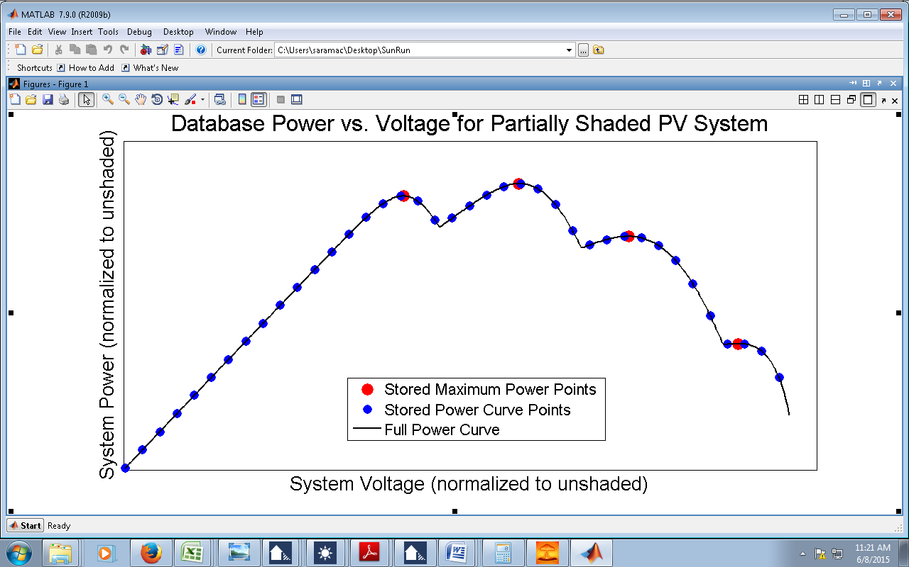

Fig. 2. Example data stored in the partial shading database. A full power vs. voltage curve (blue points) improves simulation accuracy for under-sized PV systems, or other conditions of inverter MPPT mismatch

The database is based on a 250W polycrystalline module, Trina module TSM-PA05, chosen because it has performance characteristics that are typical of crystalline silicon modules used in residential PV arrays. When the database is fully populated from 1-8 strings, its MATLAB-compressed size is 10.5MB. If each partial shading scenario is stored with just the system-level maximum power points (not the 40 points along the power curve), the size decreases by a factor of approximately four. However, this may compromise the accuracy of the performance prediction for some PV systems which are not optimally sized or configured.

*3.1.2. Database Access*

Database access requires basic information about the PV system to be simulated, including module and inverter characteristics, array configuration, unshaded and shaded plane-of-array irradiance and PV cell temperature, and the shaded fraction of each string of modules. All but the last item of this information are readily available to the user in array design documents, weather files, or datasheets. Per-string shading must be determined using a tool that maps shade patterns onto the plane of the PV array, such as the 3D shade calculator currently implemented in SAM, or other 3rd party CAD design software.

During each database access, the per-string shading and shaded (diffuse) irradiance fractions are rounded to their nearest tenth, and these are used to obtain the most relevant set of DC current and voltage system operation from the database. The maximum power output is calculated, within the PV system's inverter MPPT string voltage range, and this is then used to compute the partial shading losses. Database access time for a year of hourly points is approximately 1 second, which meets the goal of a very fast simulation time.

## 3.2 Linear shade model

## 4. Field Validation Sites

Description of data sources, and comparison simulations

Site production data: reported either on a 5-minute basis or monthly basis, depending on the data source. In addition to the PV production data, additional site metadata was obtained, such as the tilt, azimuth, and brand of the PV modules, the type of inverter equipped, and the site location.

Model meterological data: MIDC [[39]]

The shade impact database method is first validated by comparing its annual performance predictions to those of the detailed Matlab simulation tool referenced in Section II. This controls validation to focus exclusively on the database’s electrical performance prediction, because both sets of simulations have the same inputs such as weather conditions, system characteristics, and shade patterns.

*A. PV System Details*

a. 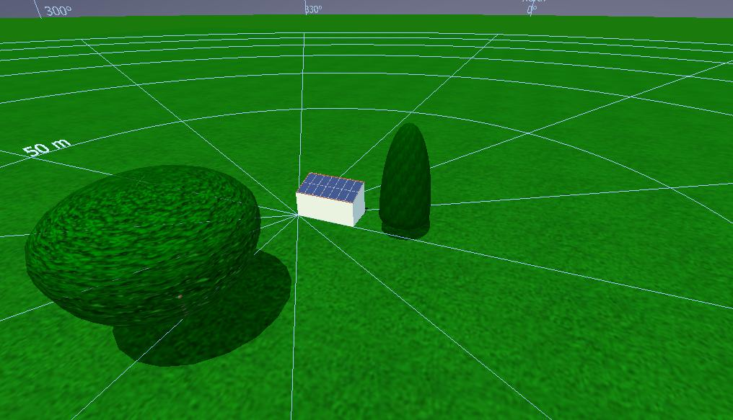

b. 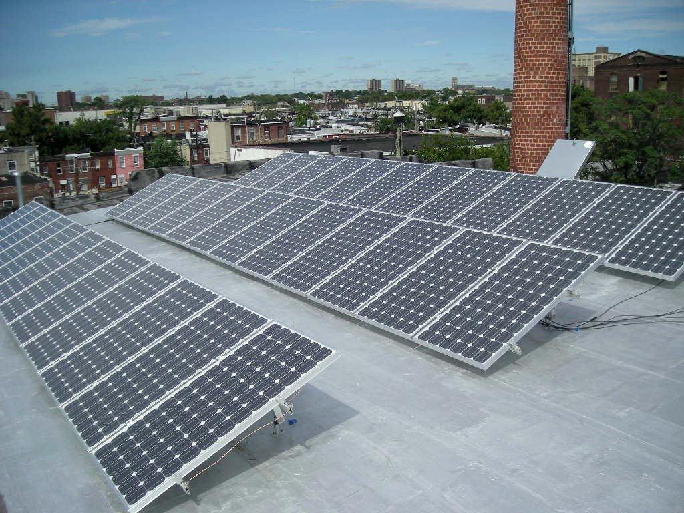

Fig. 3. Representative pictures of the 3kW (3a) and 18kW(3b) PV arrays used to validate the shade impact database.

Two PV systems are chosen for simulation, both located in Denver, Colorado. The first is a small (3kW) array with nearby shading obstacles (two large trees) shown in Fig. 3a; this system is meant to represent a typical residential installation. The second, which is similar to the PV system seen in Fig. 3b, is a larger (18kW) array with row-to-row self-shading; this system is meant to represent a typical commercial installation.

*B. Simulation Results*

As shown in Table I, the shade impact database predicts an annual shading loss within 0.8% of that predicted by the detailed simulation tool. Both the irregular shading conditions of the 3kW residential system and the regular, row-to-row shading of the commercial system are adequately addressed using the shade database method. Given the rounding of the degree and position of shading in the shade impact database, this is an excellent agreement between the simulation methods.

TABLE I

Comparison of Predicted Shade Loss



Table 1 also includes a “linear estimate” of the predicted annual shade loss, which assumes that the percent shading losses each hour are equal to the fraction of the incident irradiance blocked by nearby obstacles. This is how shading losses are currently modeled in the NREL SAM tool [**Error! Bookmark not defined.**], and is similar to simplifying assumptions used in the SunEye rooftop survey tool [10]. As shown in Table 1, the linear estimate tends to underestimate the shading losses, sometimes by a great deal; use of the shade impact database provides substantially more accurate performance predictions.

## 5. Validation Results

Shade extent uncertainty. SunEye vs 3D vs SunRoof.

CDFs of measured vs SAM modeled data

Discussion

## 6. Conclusions

To address the need for a simple way to predict the performance of partially shaded PV systems, this work proposes a lookup table style database of shade impact results (loss percentages), generated using a validated, detailed simulation tool, and encompassing a wide variety of shading scenarios. This shade impact database could be used with any annual PV simulation tool; its small size and fast access time make it suitable for a variety of applications including NREL’s SAM and PVWatts modeling tools.

Performance data from several partially shaded PV systems were used to validate use of the shade database with NREL’s SAM tool. In each case, the shade database showed improved accuracy compared to SAM’s present shade modeling capability, with performance predictions in line with those made using SunEye rooftop shading site survey data, and the detailed shade modeling in PVsyst. However, shade mapping onto the array remains a large source of uncertainty, as slight mistakes in obstacle sizing or placement may have a large impact on annual performance prediction; this is an area for future study. The shade impact database will be made available within NREL’s SAM and PVWatts simulation tools, as well as to other software developers by contacting the authors.

## Acknowledgments

Acknowledge Enphase, SunRun, Spruce Finance.

## References

# Appendix A: Obstruction diffuse irradiance loss

Importing obstruction tables from a SunEye tool or defining horizon shading loss can allow a calculation of the diffuse irradiance that is also lost by the obstructions. Beam irradiance reduction is due to the blocking of the sun’s rays, and the beam shade loss at a particular time of day depends on whether the solar position intersects a shading object at that same elevation and azimuth. Diffuse irradiance loss on the other hand is due to the reduced field of view of the solar collector to the open sky dome, and is a constant independent of solar position. Many irradiance models exist that calculate the translation of horizontal diffuse irradiance to a tilted plane. These include the Perez model, HDKR model, and isotropic model. However, these tilted plane models all assume that the horizon is un-obstructed. Accounting for horizon obstructions can update the diffuse loss term of these models, by including the additional irradiance loss from the reduced skydome area.

This method treats obstruction losses separately from the tilted-plane diffuse loss term, therefore the method is consistent with any irradiance model used in SAM (Perez, HDKR, isotropic). For the shade obstruction method discussed here, an isotropic diffuse model is assumed. The output value is an additional diffuse shading loss fraction that can be applied onto the diffuse irradiance of whichever tilted-plane model is selected.

Conceptually, a 2D integral is solved in the space where is zenith angle from vertical and is azimuth angle from north. Additionally, a 2-axis rotation is required to define zenith angle in the reference plane of the tilted, rotated PV array. This angle is calculated for tilt angle and azimuth orientation as: [[40]]

|  |  |  |
| --- | --- | --- |
|  |  | (1) |

Additionally, the projection of the PV array for a given ( in the ( coordinates is required. This is accomplished by solving , which defines the coordinates behind the plane of the PV array:

|  |  |  |
| --- | --- | --- |
|  |  | (2) |

where ArcTan2 is a 4-quadrant arctangent of (y/x) where the first argument of ArcTan2 is the x denominator, and the second argument is the y numerator.

Given these equations, diffuse irradiance is integrated for both the unshaded view of the sky and for the diffuse shading loss attributed to obstructions above the horizon. The unshaded integral considers only the portion of the sky above the horizon (, and above the view of the array plane . This is represented in Figure 1 below as the integral of open sky area above the blue array plane:

|  |  |  |
| --- | --- | --- |
|  |  | (3) |

The shaded integral considers the portion of the sky that is both visible to the array plane yet also obstructed by shading objects (. This is represented in Figure 1 below as the integral below the red horizon obstructions, and above the blue array plane.

|  |  |  |
| --- | --- | --- |
|  |  | (4) |

The weighting factor in the above diffuse integrals includes a spherical integral weighting factor , times the cosine incidence angle loss relative to the PV array normal . Note that is only defined from in the above weighting factor.



Figure 1: Example of horizon obstruction and definition of the PV array plane in elevation – azimuth coordinates for . The unshaded integral in Eq. (3) is taken over the entire sky dome visible to the array, excluding the area behind the plane (blue). The shaded integral in Eq. 4 is included over the area below the horizon obstruction (red). Note that the area below the horizon represents the diffuse loss of a tilted plane relative to horizontal (grey) and is typically handled by a separate transposition model.

The overall fraction of diffuse irradiance lost to horizon shade is . This loss term varies throughout the array, since the obstruction zenith angle depends on the position within the array. Strictly speaking, should be tabulated separately for each PV module in the array. However, variation within the array tends to be small, and unlikely to introduce additional mismatch losses. Therefore, in the SAM approach, is averaged across the array, and applied as a single diffuse loss fraction.

1. Kahn E. Avoidable transmission cost is a substantial benefit of solar PV. *The Electricity Journal*, 2008; **21:** 41-50.
2. Hoff TE, Wenger HJ, Farmer BK. Distributed generation: an alternative to electric utility investments in system capacity. *Energy policy* 1996; **24**: 137-147.
3. Levinson, R., Akbari, H., Pomerantz, M. and Gupta, S., 2009. Solar access of residential rooftops in four California cities. *Solar Energy*, *83*(12), pp.2120-2135.
4. Tsoutsos T, Frantzeskaki N, Gekas V. Environmental impacts from the solar energy technologies. *Energy Policy*, 2005; *33*(3):.289-296.
5. Goodrich A, James T, Woodhouse M. Residential, commercial, and utilityscale photovoltaic (PV) system prices in the United States: current drivers and cost-reduction opportunities. NREL technical report NREL/TP-6A20-53347 2012, http://www.nrel.gov/docs/fy12osti/53347.PDF
6. Woyte A, Nijs J, Belmans R. Partial shadowing of PV arrays with different system configurations: literature review and field test results. Solar Energy 2003; **74:** 217-233
7. Femia N, Lisi G, Petrone G, Spagnuolo G, Vitelli M. Distributed Maximum Power Point Tracking of Photovoltaic Arrays: Novel Approach and System Analysis. IEEE Transactions on Industrial Electronics 2008; **55:** 2610-2621.
8. MacAlpine S, Erickson R, Brandemuehl M. Characterization of Power Optimizer Potential to Increase Energy Capture in Photovoltaic Systems Operating Under Nonuniform Conditions. *IEEE Transactions on Power Electronics* 2013; **28:** 2936-2945.
9. Hanson A, Deline C, MacAlpine S, Stauth J, Sullivan C. Partial-Shading Assessment of Photovoltaic Installations via Module-Level Monitoring. IEEE Journal of Photovoltaics 2014; **4**: 1618-1624
10. MacDonald WS, Solmetric Corporation, 2011. *Skyline imaging system for solar access determination*. U.S. Patent 7,861,422.
11. Solar Pathfinder, 2008. Instruction Manual For The Solar Pathfinder. *Linden, TN. Available on-line at: http://www. solarpathfinder.com/pdf/pathfinder-manual.pdf*.
12. Jochem A, Höfle B, Rutzinger M, Pfeifer N. Automatic roof plane detection and analysis in airborne lidar point clouds for solar potential assessment. *Sensors*, 2009; *9*(7): 5241-5262.
13. Jakubiec JA, Reinhart CF. A method for predicting city-wide electricity gains from photovoltaic panels based on LiDAR and GIS data combined with hourly Daysim simulations. *Solar Energy* 2013; **93***:* 127-143.
14. Izquierdo S, Rodrigues M, Fueyo N. A method for estimating the geographical distribution of the available roof surface area for large-scale photovoltaic energy-potential evaluations. *Solar Energy*, 2008; *82*(10): 929-939.
15. Melius J, Margolis R, Ong S. Estimating rooftop suitability for PV: a review of methods, patents, and validation techniques. *National Renewable Energy Laboratory*, 2013 http://www.nrel.gov/docs/fy14osti/60593.pdf.
16. Drif M, Perez PJ, Aguilera J, Aguilar JD. Renewable Energy 2008; **33:** 2048–2056.
17. Poshtkouhi S, Palaniappan V, Fard M,Trescases O. A General Approach for Quantifying the Benefit of Distributed Power Electronics for Fine Grained MPPT in Photovoltaic Applications using 3D Modeling. IEEE Transactions on Power Electronics 2012; **27:** 4656-4666.
18. Deline C. Partially shaded operation of a grid-tied PV system. Proceedings of 34th IEEE Photovoltaic Specialists Conference (PVSC), 2009: 1268-1273.
19. Bishop JW. Computer simulation of the effects of electrical mismatches in photovoltaic cell interconnection circuits. Solar cells 1988; **25:** 73-89.
20. Quaschning V, Hanitsch R. Irradiance calculation on shaded surfaces. Solar Energy 1998;  **62:** 369-375.
21. Patel H, Agarwal V. MATLAB-based modeling to study the effects of partial shading on PV array characteristics. *IEEE transactions on energy conversion*, 2008; **23:** 302-310.
22. Olalla C, Clement D, Maksimović D, Deline C. A cell-level photovoltaic model for high-granularity simulations. Proceedings, 15th IEEE European Conference on Power Electronics and Applications*, 2013*.
23. Sinapis K, Tzikas C, Litjens G, van den Donker M, Folkerts W, van Sark, W, Smets A. A comprehensive study on partial shading response of c-Si modules and yield modeling of string inverter and module level power electronics. *Solar Energy* 2016;**135:** 731-741.
24. NREL. (2014). NREL System Advisor Model (SAM). Retrieved August 2014, from https://www.nrel.gov/analysis/sam/
25. NREL. (2014). PV Watts Calculator. Retrieved August 2014, from http://pvwatts.nrel.gov/
26. Deline C, Dobos A, Janzou S, Meydbray J, Donovan M. A simplified model of uniform shading in large photovoltaic arrays. *Solar Energy* 2013;**96**: 274-282.
27. Brecl K, Topič M. Self-shading losses of fixed free-standing PV arrays. *Renewable energy* 2011; **36:** 3211-3216.
28. Petrone G, Spagnuolo G, Vitelli M. Analytical model of mismatched photovoltaic fields by means of Lambert W-function. Solar Energy Materials and Solar Cells 2007; **91**:1652-1657.
29. Paraskevadaki EV, Papathanassiou SA. Evaluation of MPP voltage and power of mc-Si PV modules in partial shading conditions. IEEE Transactions on Energy Conversion 2011; **26:** 923-932.
30. Martínez-Moreno F, Muñoz J, Lorenzo E. Experimental model to estimate shading losses on PV arrays. Solar Energy Materials and Solar Cells, 2010; **94:** 2298-2303.
31. MacAlpine S, Deline C. Simplified method for modeling the impact of arbitrary partial shading conditions on PV array performance. Proceedings, 42nd IEEE Photovoltaic Specialist Conference , 2015. DOI: 10.1109/PVSC.2015.7355938
32. Perez R, Ineichen P, Seals R, Michalsky J, Stewart R. Modeling daylight availability and irradiance components from direct and global irradiance. Solar energy 1990; **44:**.271-289.
33. Reindl DT, Beckman WA, Duffie JA. Evaluation of hourly tilted surface radiation models. Solar energy, 1990; **45:** 9-17.
34. PVsyst. (2015). PVsyst Photovoltaic Software. Retrieved May 2015, from http://www.pvsyst.com/en
35. Tomori T, Otani K., Sakuta K, Kurokawa K. On-site BIPV array shading evaluation tool using stereo-fisheye photographs. Proceedings, 28th IEEE *Photovoltaic Specialists Conference, 2000:*  1599-1602.
36. J. A. Duffie andW. A. Beckman, *Solar Engineering of Thermal Processes*. Hoboken, NJ: John Wiley & Sons, 2006, ch. 1–23.
37. M. Boyd, S. Klein, D. Reindl, and B. Dougherty, “Evaluation and validation of equivalent circuit photovoltaic solar cell performance models,” *J.Sol. Energy Eng.*, vol. 133, no. 2, pp. 021005-1–021005-13, May 2011.
38. S. MacAlpine and M. Brandemuehl, “Photovoltaic module model accuracy at varying light levels and its effect on predicted annual energy output,” presented at the 37th IEEE Photovoltaic Specialists Conf., Seattle, WA, 2011.
39. NREL. (2015). MIDC/SRRL Baseline Measurement System. Retrieved April 2015, from http://www.nrel.gov/midc/srrl_bms/
40. . V. Badescu, “3D isotropic approximation for solar diffuse irradiance on tilted surfaces” Renewable Energy **26** pp.221-233, 2002